Bahria University,

Karachi Campus



LAB EXPERIMENT NO.

**07**

LIST OF TASKS

|  |  |
| --- | --- |
| TASK NO | OBJECTIVE |
| 1 | **Create static library that will used for three functions, addition, multiplication, subtraction.** |
| 2 | **Create Dynamic library that will used for the multiple of 5.** |
| 3 | **Create static library that will used for cube of 10.** |

Submitted On:

**26/12/2022**

**Task # 01: Create static library that will used for three functions, addition, multiplication, subtraction.**

**Solution:**

#include<iostream>

#include"Header.h"

using namespace std;

int main() {

cout << "Enter First Number : " ;

int a, b;

cin >> a;

cout << "Enter Second Number : " ;

cin >> b;

cout << "\nAddition: " << Addition(a, b) << endl;

cout << "\nSubtraction: " << Substraction(a, b) << endl;

cout << "\nMultiplication: " << Multiplication(a, b) << endl;

cout << "\nDivision: " << Division(a, b) << endl;

return 0;

}

**Library Code:**

#ifndef _calc_h_

#define _calc_h_

double Addition(int x, int y) {

return x + y;

};

double Substraction(int x, int y) {

return x - y;

};

double Multiplication(int x, int y) {

return x * y;

};

double Division(int x, int y) {

return x / y;

};

**Output:**

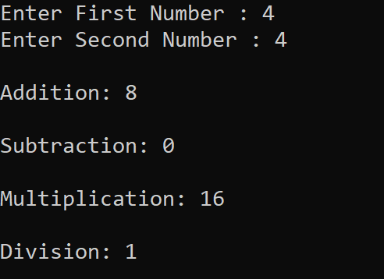

**Task # 02: Create Dynamic library that will used for the multiple of 5.**

**Solution:**

#include<iostream>

#include"Source.cpp"

using namespace std;

int main() {

cout << "Enter number: ";

int n;

cin >> n;

Check(n);

return 0;

}

**Libraries files**

**Header.h file:**

#ifndef _mul5_h_

#define _mul5_h_

void Check(int n);

#endif

**Source.cpp file:**

#ifndef mul5_C_

#define mul5_C_

#include "Header.h"

#include<iostream>

using namespace std;

void Check(int num) {

if ((num % 5) == 0) {

cout << "Number is multiple of 5" << endl;

}

else {

cout << "Number is not multiple of 5" << endl;

}

}

#endif

**Output:**

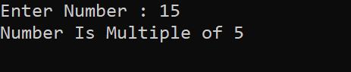

**Task # 03: Create static library that will used for cube of 10.**

**Solution:**

#include<iostream>

#include"Header.h"

using namespace std;

int main() {

cout << "Enter number: ";

int n;

cin >> n;

if (n == 10) {

cout << "Cube: " << cube10(n) << endl;

}

else {

cout << "Number is not 10" << endl;

}

return 0;

}

**Library File:**

**Header.h:**

#ifndef _cube10_h_

#define _cube10_h_

int cube10(int n) {

return n * n * n;

}

#endif

**Output:**



